MH10.8.6 – 200?



Bar Codes and Two-Dimensional (2D) Symbols for Product Packaging

Approved: XX Xxxxxx 200x

Abstract
This standard is an application standard for the marking of product packages with linear bar code and two-dimensional symbols. It defines minimum requirements for identifying product packages that are distributed outside the originating location. It specifies label data content and requirements, including data element requirements; data representation; rules for encoding of mandatory and optional elements in machine-readable symbols; and human readable information.

Developed by:

MH10 Committee, Unit-Loads and Transport-Packages
Subcommittee 8, Coding & Labeling of Unit-Loads

Published by MH10 Secretariat:

Material Handling Industry of America
8720 Red Oak Blvd., Suite 201
Charlotte, NC 28217-3992
mhstandards@mhia.org



American National Standard

Approval of an American National Standard requires verification by ANSI that the requirements for due process, consensus, and other criteria for approval have been met by the standards developer.

Consensus is established when, in the judgement of the ANSI Board of Standards Review, substantial agreement has been reached by directly and materially affected interests. Substantial agreement means much more than a simple majority, but not necessarily unanimity. Consensus requires that all views and objections be considered, and that a concerted effort be made toward their resolution.

The use of American National Standards is completely voluntary; their existence does not in any respect preclude anyone, whether he has approved the standards or not, from manufacturing, marketing, purchasing, or using products, processes or procedures not conforming to the standards.

The American National Standards Institute does not develop standards and will in no circumstances give an interpretation of any American National Standard. Moreover, no person shall have the right or authority to issue an interpretation of an American National Standard in the name of the American National Standards Institute. Requests for interpretations should be addressed to the sponsor whose name appears on the title page of this standard.

CAUTION NOTICE: This American National Standard may be revised or withdrawn at any time. The procedures of the American National Standards Institute require that action be taken periodically to reaffirm, revise or withdraw this standard. Purchasers of American National Standards may receive current information on all standards by calling or writing the American National Standards Institute.

© 2004 by Material Handling Industry of America (MHIA)
All rights reserved.

No part of this publication may be reproduced in any form,
in an electronic retrieval system or otherwise, without
prior written permission of the Materials Handling Institute of America,
MH10 Secretariat, 8720 Red Oak Blvd., Suite 201, Charlotte, NC 28217-3992
Phone: 704-676-1190, Fax: 704-676-1199

Printed in the United States of America.

ANS MH10.8.6 – 200x

American National Standard

Bar Codes and Two-Dimensional (2D) Symbols for Product Packaging

Developed by:

MH10 Committee, Unit-Loads and Transport-Packages
Subcommittee 8, Coding & Labeling of Unit-Loads

Published by MH10 Secretariat:

Material Handling Industry of America
8720 Red Oak Blvd., Suite 201
Charlotte, NC 28217

Approved Xxxxxx XX, 200x
American National Standards Institute, Inc.

Disclaimer

This standard, which was developed under the ANSI Committee method and approved by ANSI on XX Xxxxxx 200x, represents suggested design practices and guidance for the marking of product packaging with linear bar code and two-dimensional symbols. It was developed with the sole intent of offering information to parties engaged in the manufacture, marketing, purchase, or use of automatic identification equipment software and services. This standard is advisory only and acceptance is voluntary and the standard should be regarded as a guide that the user may or may not choose to adopt, modify, or reject. The information does not constitute a comprehensive safety program and should not be relied upon as such. Such a program should be developed and an independent safety adviser consulted to do so.

Material Handling Industry (MHI), the MH10 Committee and its members assume no responsibility and disclaim all liability of any kind, however arising, as a result of acceptance or use or alleged use of this standard. User specifically understands and agrees that MHI, the MH10 Committee, committee officers, agents, and members shall not be liable under any legal theory of any kind for any action or failure to act with respect to the design, installation, manufacture, preparation for sale, sale, characteristics, features, or delivery of anything covered by this standard. Any use of this information must be determined by the user to be in accordance with applicable federal, state, and local laws and regulations.

MHI, the MH10 Committee and its members make no warranties of any kind, express, implied, or statutory, in connection with the information in this standard. MHI and the MH10 Committee specifically disclaim all implied warranties of merchantability or of fitness for particular purpose.

By referring to or otherwise employing this standard, the user agrees to defend, protect, indemnify, and hold MHI, the MH10 Committee, committee officers, agents, and members harmless from and against all claims, losses, expenses, damages, and liabilities, direct, incidental, or consequential, arising from acceptance or use or alleged use of this standard, including loss of profits and reasonable attorneys' fees which may arise out of the acceptance or use or alleged use of this standard. The intent of this provision and of the user is to absolve and protect MHI, the MH10 Committee, committee officers, agents, and members from any and all loss relating in any way to this standard, including those resulting from the user's own negligence.
Foreword (This foreword is not part of American National Standard MH10.8.6-200x)

This standard is an application standard for the marking of product packages with linear bar code and two-dimensional symbols. If defines minimum requirements for identifying product packages that are distributed outside the originating location. It specifies label data content and requirements, including data element requirements; data representation; rules for encoding of mandatory and optional data elements in machine-readable symbols; and human readable information.

Bar codes and Two-Dimensional (2D) Symbols for Product Packaging provides the option of one of four different linear bar code symbols and one of three different two-dimensional symbols. It relies upon the technology standards and data semantic and syntax standards developed within ASC MH10. These standards have in turn been published internationally through the work of ISO/IEC JTC 1/SC 31.

The international equivalent of this standard is the international standard ISO 22742, developed by ISO Technical Committee 122/Working Group 7. ANS MH10.8.6 and ISO 22742 were developed concurrently and differ primarily with a recommended/preferred two-dimensional symbol in the ANS while the ISO standard provides no such recommendation or preference.

At the time of approval, the MH10/SC 8 committee consisted of the following members:

Automotive Industry Action Group Morris Brown

Bruno Associates Thomas Bruno
Canada Post Ken Cavanagh

DoD AIT Project Office Maurice Stewart; Dan Kimball (Alternate); Eugene Bransfield (Alternate)
Federal Express Mark Thomas
General Motors Larry Graham
Handheld Products Robert Hussey
HighTech Aid Steve Halliday
IBM Charles Milligan
Intermec Technologies Michael Guillory

Q.E.D. Systems Craig K. Harmon; Marsha A. Harmon (Alternate)
RVSI Luis Flgarella
Rylander Associates Robert Rylander
Symbol Technologies Christina Barkan
Telcordia Technologies Robert Fox
Texas Instruments Dan Wikander
United Parcel Service Mark Lewis
United States Air Force Mark Reboulet; Howard English (Alternate)
United States Navy Gary Bruner, Allan Ggilligan (Alternate)
United States Postal Service Himesh Patel

At the date of approval of this standard, the MH10 Committee, Unit-Loads and Transport-Packages, consisted of the following members:

AIM, USA
American Trucking Associations
American Wood Packaging Association
APA – The Engineered Wood Association
Assoc. of Professional Material Handling Consultants
ASTM
Automotive Industry Action Group
Comp TIA
Containerization & Intermodal Institute
Electronics Industries Association
Fibre Box Association
Flexible Intermediate Bulk Containers Association
Food Marketing Institute
Glass Packaging Institute
Graphic Communications Association
IMC & WD
Institute of Packaging Professionals
Integrated Business Communications Alliance
International Cargo Handling Coordination Assoc.
International Safe Transit Association
Material Handling Industry
Material Handling Management Society
National Wholesale Grocer's Association
National Wooden Pallet & Container Association
Plastic Drum Institute
Q.E.D. Systems
Rack Manufacturers Institute
Reusable Industrial Packaging Association
Steel Shipping Container Institute
Textile Bag Manufacturers Association
The Soap & Detergent Association
U.S. Dept. of Agriculture
U.S. Dept. of Defense Logistics
U.S. Forest Products Laboratory
Uniform Code Council
United Fresh Fruit & Vegetable Association

Suggestions for improvement, and questions regarding interpretation of this standard will be welcome. They should be sent to: MH 10 Committee (MHIA), Material Handling Industry of America, 8720 Red Oak Blvd., Suite 201, Charlotte, NC, 28217-3992 or mhstandards@mhia.org.

AMERICAN NATIONAL STANDARD ANS MH10.8.6 – 200X

BAR CODES AND TWO-DIMENSIONAL (2D) SYMBOLS FOR PRODUCT PACKAGING

Table of Contents

5.6.4 Label Location 27
1 SCOPE 5
2 PURPOSE 5
3 NORMATIVE REFERENCES 6
4 DEFINITIONS 7
5 LABEL DATA CONTENT AND REQUIREMENTS 7
5.1 Rules for Encoding of Mandatory and Optional Data Elements in Machine Readable Symbols and Human Readable Information. 8
5.1.1 General Rules 8
5.1.2 Rules for Mandatory Data Elements. 8
5.1.2.1 Encoding Mandatory Elements in Machine Readable Symbols. 8
5.1.2.2 Human Readable Information for Encoded Data Elements. 8
5.1.3 Rules for Additional Data Elements Specified in 5.3 9
5.1.3.1 Encoding in Machine Readable Symbols. 9
5.1.3.2 Human Readable Information for Encoded Data Elements 9
5.1.3.3 Human Readable Information for Data Elements Not Encoded 9
5.2 Mandatory Data Elements 9
5.2.1 Item Identification 11
5.2.2 Quantity 12
5.2.3 Traceability Identification 13
5.2.3.1 Serial Number 16
5.2.3.2 Traceability Number 16
5.3 Additional Data Elements 16
5.3.1 Supplier Information 17
5.3.2 Country of Origin 19
5.3.3 Others Not Specified in this Standard 21
5.4 Data Representation 21
5.4.1 General Formatting 21
5.4.2 General Formatting for Machine Readable Symbols 21
5.4.2.1 Linear Bar Code 21
5.4.2.1.1 Syntax 21
5.4.2.2 2D Symbols 21
5.4.2.2.1 Data Element Syntax for 2D Symbols 21
5.4.2.2.2 Data Element Syntax for Application Identifier Data Encoded in 2D Symbols 22
5.4.3 General Formatting for Human Readable Information 23
5.4.3.1 Human Readable Interpretation 23
5.4.3.2 Human Translation 23
5.4.3.3 Data Area Titles 23
5.4.3.4 Free Text and Data 25
5.5 Data Carriers 25
5.5.1 Data Carrier Selection 25
5.5.2 General Symbology Requirements 25
5.5.2.1 Linear Symbologies Requirements 25
5.5.2.1.1 Selected Symbologies 26
5.5.2.1.2 Symbol Requirements for Linear Bar Code Symbols 26
5.5.2.2 Two Dimensional (2D) Symbols Used on Product Packages 28
5.5.2.2.1 "X" Dimension 30
5.5.2.2.2 Print Quality 30
5.5.2.2.3 Error Correction Level 30
5.5.2.2.4 Syntax and Semantic Recommendations 30
5.6 Label Size and Layout 30
5.6.1 Label Size 30
5.6.2 Label Layout 30
5.6.3 Examples of Label and Label Layout 30
5.6.3.1 Examples of Labels with Linear Bar Code and Human Readable Information 30
5.6.3.2 Labels with 2D Symbols and Human Readable Information 32
5.6.3.3 Label with Linear Bar Code, 2D Symbol and Human Readable Information 33
5.6.4 Label Location 34
Annex A – Informative References 35
Annex B – Glossary (normative) 36
Bibliography 48
Normative Reference Acquisition 48

AMERICAN NATIONAL STANDARD ANS MH10.8.6 – 200x

BAR CODES AND TWO-DIMENSIONAL (2D) SYMBOLS FOR PRODUCT PACKAGING

SCOPE

This standard:

- specifies the minimum requirements for the design of labels containing linear bar code and two-dimensional symbols on product packages to convey data between trading partners,

- provides guidance for the formatting on the label of data presented in linear bar code, two-dimensional symbol or human readable form,

- provides specific recommendations regarding the choice of linear bar code and 2D symbologies, specifies quality requirements, classes of bar code density,

- provides specific recommendations regarding 2D symbologies that allows a broad choice for general use of scanning hardware, specifically, area imagers, single line laser scanners, and rastering laser scanners, and

- makes recommendations as to label placement, size and the inclusion of free text and any appropriate graphics.

In this document, the word "shall" indicates a requirement and the word "should" indicates a recommendation. Both labels and direct marking methods are referred to in this standard under the term "label".

This standard does not supersede or replace any applicable safety or regulatory marking or labeling requirements. This standard is meant to satisfy the minimum product package requirements of numerous applications and industry groups. As such its applicability is to a wide range of industries, each of which may have specific implementation guidelines for this standard. This standard is to be applied in addition to any other mandated labeling requirements.

Before implementing this specification, suppliers and manufacturers should review and mutually agree on specific labeling details with their trading partners. The labeling requirement of this standard and other standards may be combined into one label or appear as separate labels.

This standard does not supersede or replace any applicable safety or regulatory marking or labeling requirements. This standard is meant to satisfy the minimum product package requirements of numerous applications and industry groups. As such its applicability is to a wide range of industries, each of whom may have specific implementation guidelines for this standard. This standard is to be applied in addition to any other mandated labeling requirements.

PURPOSE

The purpose of this standard is to establish the machine readable (e.g. bar code) and human readable data content of labels applied to product packages.

NORMATIVE REFERENCES

ISO 3166-1, Codes for the representation of names of countries and their subdivisions — Part 1: Country codes

ISO 8601, Data elements interchange formats — Information interchange — Representation of dates and times
ISO/IEC 15415, Information technology — Automatic identification and data capture techniques — Bar code print quality test specification — Two-dimensional symbols
ISO/IEC 15416, Information technology — Automatic identification and data capture techniques — Bar code print quality test specification — Linear symbols
ISO/IEC 15417, Information technology — Automatic identification and data capture techniques — Code 128 bar code symbology specification
ISO/IEC 15418, Information technology, Automatic identification and data capture techniques – GS1 Application Identifiers and ASC MH 10 Data Identifiers
ISO/IEC 15434, Information technology — Automatic identification and data capture techniques – Syntax for high capacity ADC media
ISO/IEC 15438, Information technology — Automatic identification and data capture techniques — PDF417 bar code symbology specification
ISO/IEC 15459-1, Information technology — Unique identifiers — Part 1: Unique identifiers of transport units
ISO/IEC 16022, Information technology – Automatic identification and data capture techniques – Bar code symbology specification – Data Matrix
ISO/IEC 16388, Information technology — Automatic identification and data capture techniques — Code 39 bar code symbology specification
ISO/IEC 18004, Information technology — Automatic identification and data capture techniques — QR Code 2005 bar code symbology specification
ISO/IEC 19762 (all parts), Information technology — Automatic identification and data capture techniques – Harmonized vocabulary
ANS MH10.8.2, Data Identifier and Application Identifier Standard
ANS MH10.8.3, Syntax for High Capacity ADC Media
ANS HIBC 2, Health Industry Supplier Labeler Standard
GS1 General Specifications

DEFINITIONS

For the purposes of this document, the terms and definitions given in ISO/IEC 19762 and those in Appendix B apply.

LABEL DATA CONTENT AND REQUIREMENTS

The label format accommodates both mandatory and optional data elements.

The number included in character count is exclusive of overhead characters such as start and stop characters, data identifiers or application identifiers and any other characters required by a standard symbology specification to properly encode data.

All data elements encoded in a machine-readable medium shall be preceded by the appropriate Data Identifier (DI) defined in ISO/IEC 15418 and ANS MH10.8.2 Data Identifier or the appropriate Application Identifier (AI) defined in ISO 15418 ISO/IEC and the GS1 General Specifications.

The choice between GS1 Applications Identifiers or Data Identifiers for any user will normally be defined in the applicable industry convention being followed. It is recommended that data structures used to identify products or the traceability of products include identification of the organization providing the coding as well as the specific coding structure.

Other industries developing product or shipment identification conventions should consider business practices, information requirements and systems capabilities of the trading partners in choosing between Data Identifiers and GS1 Applications Identifiers. The user may also consider the following guidelines:

- Data Identifiers (DIs):

The descriptions in the Data Identifier list are general in nature and are used in industrial and international applications. Specific application guidelines provide the detailed definition used amongst trading partners.

The full list of registered Data Identifiers (DIs) and the full specification for their use are found in the American National Standard MH10.8.2.

DIs may be used with any alphanumeric data carrier and are designed to ensure cross-industry commonality of data identifiers used in automatic identification technologies.

DIs have a format of one alphabetic character alone, or one alphabetic character prefixed by one, two or three numeric characters.

- GS1 Application Identifier (AIs):

The definitions of the GS1 Application Identifiers (AIs) are supported by application guidelines. The GS1 AIs, and associated guidelines, have been designed for international and multi-sectorial trading purposes.

The GS1 item identification system and related encodation standard are complemented by the GS1 maintained Application Identifiers, hereafter referred to as "GS1 Applications Identifiers" (GS1 AIs). This standard comprises two principal elements which are the key to any encoding system: the data content and the data carrier.

The use of GS1 AIs is subject to the rules established by GS1.

GS1 AIs identify generic and simple data fields for use in cross-sectorial and international supply chain applications. The GS1 General Specifications provide rules for the definition, format and structure of the data fields.

Each GS1 AI consists of two or more characters. The first two digits determine the length of the AI. A list of two digit codes indicating the predefined length of existing and future AIs and their data fields is contained within the GS1 General Specifications.

In the GS1 General Specifications this coding structure is the company prefix portion of the GTIN (Global Trade Item Number) or GLN (Global Location Number).

When using Data Identifiers this coding structure uses the Issuing Agency Code (IAC) established in ISO/IEC 15459-1 and the Company Identification Number (CIN) assigned by the issuing agency.

  - Rules for Encoding of Mandatory and Optional Data Elements in Machine Readable Symbols and Human Readable Information.

    - General Rules

The choice to encode in linear bar code, 2D symbol or both is to be agreed upon between trading partners.

All machine readable Data Elements shall be preceded by the appropriate Data Identifier or Application Identifier. The Data or Application Identifier should be selected from the options given in clause 5.1 and shall be in accordance with ISO/IEC 15418.

    - Rules for Mandatory Data Elements.

      - Encoding Mandatory Elements in Machine Readable Symbols.

Mandatory data elements (see 5.2) shall be encoded in a machine-readable symbol:

- If only a linear bar code is used, the mandatory data shall be in the linear bar code.

- If both a linear bar code and 2D symbol are used on the label, the mandatory data shall be in the linear bar code and the 2D symbol.

- If only a 2D symbol is used, the mandatory data shall be in the 2D symbol.

- The use of a 2D symbol must be accompanied by the linear bar code of the mandatory data fields unless mutually agreed upon between trading partners.

      - Human Readable Information for Encoded Data Elements.

Human readable information for mandatory data elements shall be on the label in all cases.

- For linear symbols the human readable shall be human readable interpretation.

- For 2D symbols the human readable shall be human translation.

When mandatory data is only in the 2D symbol the mandatory human readable shall be human translation.

    - Rules for Additional Data Elements Specified in 5.3

      - Encoding in Machine Readable Symbols.

Additional data elements should be encoded in a machine-readable symbol.

- If only linear bar codes are used, the data should be in the linear bar code.

- If both linear bar codes and 2D symbol are used: Data should be in linear bar code and should be included in 2D. If the data are included in the linear bar code the data shall also be included in the 2D symbol.

- If only a 2D symbol is used, the data should be in the 2D symbol.

      - Human Readable Information for Encoded Data Elements

Human Readable Information for Optional Data Elements encoded in a linear symbol shall be on
the label in all cases. In this case Human Readable Interpretation shall be present and Human
Translation may be added.

For Data Elements encoded in 2D symbols the Human Readable Information should be on the label and it shall be shown in Human Translation.

      - Human Readable Information for Data Elements Not Encoded

Human Readable Information for additional data elements that are not encoded in machine
readable symbols may be shown in Human Readable Information only.

  - Mandatory Data Elements

Certain data elements are fundamental to a broad range of product package applications. These
are:

- Item Identification code

- Quantity without or Quantity with unit of measure

- Traceability Identification (

- Serial Number or Traceability Number)

Note: Certain Item Identification codes imply a quantity other than one.

Whether a data element is mandatory or optional may be dependent on industry, market, or individual trading partner requirements. These data elements may be human readable, machine-readable, or both. If machine-readable the data elements shall be in accordance with ISO/IEC
15418.

Table 1 – Machine-readable Symbols and Human Readable Information.

Data Element Status | Machine Readable Symbols On Label | Requirement for Encoding |  | Requirement forHuman Readable Information
 |  | Bar | 2D
Mandatory | Bar | shall |  | shall
Mandatory | Bar + 2D | shall | Shall | shall
Mandatory | 2D |  | Shall | shall
Optional  Specified  Note 1 | Bar | should |  | shall if encoded
Optional  Specified  Note 1 | Bar + 2D | should  Note 2 | Should | shall if encoded in Bar
Optional  Specified  Note 1 | 2D |  | Should | should if encoded
Optional  Specified  Note 1 | No |  |  | may
Optional  Not specified  Note 1 | Bar | may |  | shall if encoded
Optional  Not specified  Note 1 | Bar + 2D | may | May | shall if encoded in Bar
Optional  Not specified  Note 1 | 2D |  | Should | may if encoded
Optional  Not specified  Note 1 | No |  |  | may
1. “Specified Optional Data Elements” are in this standard Supplier Item Identification, and Country of Origin. All Others belong to the category “Optional data elements not specified”.
2. If the data element is encoded in Linear Bar Code it shall also be included in the 2D symbol.

Table 2 – Data Element Usage

Data Element | Market Sector | Requirement
Item Identification Code | Industrial | Required
 | Retail | Required
Quantity | Industrial | Required. Note that some manufacturers may change the product code to represent a change in quantity. Regardless, of whether the package contains one of an item or the package contains more than one, the quantity shall be encoded,
 | Retail | Required. Note that in the case of encoding item identification in an GS1 GTIN, the quantity is reflected by a change in the GTIN.
Traceability Identification | Industrial | Required
 | Retail | Optional

- Optional data elements can be country or industry specific mandatory.

    - Item Identification

Item Identification may be assigned by either the Supplier or the Customer. Either the Customer Item Identification or the Supplier Item Identification or both may be shown on the label as agreed to between the trading partners. If both are shown on the label at least one of the two item identifiers shall be encoded in a machine-readable symbol.

The supplier's part number shall be used for Item Identification in the absence of a different agreement between trading partners.

The maximum length of this data element shall be 25 alphanumeric characters, not including the appropriate identifier (AI or DI) and other overhead characters. When item identification is combined with supplier identification into a single data element, the maximum length of this field shall not exceed 32 alphanumeric characters not including the appropriate identifier (AI or DI) and other overhead characters.

The item identification data field should be in one of the formats below. These identifiers represent the most frequently used formats for product package. The complete list of possible item identification codes can be found in ANS MH10.8.2 or the GS1 General Specifications.

Table 3 – DIs Used In Item Identification

Data Identifier | Data Field | Data characteristics  Type/length | Description
P | Product Number | an1+an...25 | Customer Assigned Part Number
1P | Product Number | an2+an...25 | Supplier Assigned Part Number
8P | Product Number | an2+n14 | GS1 GTIN
11P | Product Number | an3+an10 | CLEI Code for telecommunications equipment
25P | Product Number | an3+an...32 | Combined IAC/CIN and item code assigned by the supplier
+ | Product Number | a1+an..19 | HIBCC

Table 4 – AIs Used in Item Identification

Application Identifier | Data Field | Data characteristics  Type/length | Description
N/A | Global Trade Identification Number (GTIN) | n8..14 | Global Trade Item Number: Shorthand term for the GS1 Global Trade Item Number. A GTIN may use the GS1-8, UCC-12, GS1-13 or GS1-14 standard numbering structure.
01 | GTIN | n2+n14 | GTIN Used primarily in GS1-128 symbology
02 | GTIN (variable count) | n2+n14 | Trade Item printed in GS1-128 symbology in a logistic unit to be used with AI 37
37 | Count | n2+n..8 | Count of trade items contained in a logistic unit
241 | Part Number | n3+an...25* | Customer Assigned Part Number
8001 | Roll Products | n4+n14 | Roll Products - Width, Length, Core Diameter, Direction And Splices
8006 | Identification of the Components of a Trade Item | n4+n14+n2+n2 | GS1 Identification of a Fixed Measure Trade Item (GCTIN) packed in separate parcels.
8018 | Global Service Relation Number (GSRN) | n4+n18 | GS1 identification number of a service relation (GSRN) to be assigned by the service provider.
8020 | Payment Slip Reference Number | n4+an..25 | Payment slip reference number.

* Table Note: GS1 permits AI "241" to be a maximum of 30 characters. This standard recommends the Customer Assigned Part Number to be limited to no more than 25 characters.

Key Number Structures

(01) = Application Identifier for -14 number

Figure 2

    - Quantity

Unless otherwise specified, the implied quantity of the product identified on the outside of the product package is one.

Two primary methods exist of identifying the quantity inside a product package.

- The first situation is where the product package identifies the product code and the
quantity contained therein on the product package label. This may be analogous to a raw material being received where 10 of an item are received in the same box and the product package identifies 10 products having the same product code. In this situation the quantity would be considered to be ten.

- The second situation is where a quantity of product and its packaging are identified by a product code different from the product code assigned to the product inside. This may be analogous to a consumable unit, e.g. batteries, where the combination of the items, quantity, and packaging constitute a unique product code. In this situation the quantity would be considered to be one.

If used, the Quantity shall be the quantity in the package or container to which the label is affixed. The default unit of measure for Data Identifier "Q" is EACH or "PIECES". The default unit of measure for Application Identifier "30" is EACH or "PIECES".

When the GS1 GTIN 14 product identifier is used in the Product Identification data field, a separate Quantity field is not required to be included as part of the label because the GTIN normally has a quantity associated with it. See the GS1 General Specifications for details on exceptions.

When Data Identifiers are used and when a different unit of measure is required, as agreed to between trading partners, the Data Identifier "7Q" shall be used with the quantity followed by two alphanumeric characters representing the ANS X.12.3 unit of measurement code. In the special case where multiple containers comprise a single product (the contents of each container must be combined with the content of the other containers to constitute a single product) the Data Identifier "6Q" or Application Identifier "8006" shall be used to link the various containers.

When Application Identifiers are used and when a different unit of measure is required, as agreed to between trading partners, one of the Application Identifiers in the "3nn" series, as specified in the GS1 General Specifications shall be used with a decimal point indicator and the quantity. ANSI MH10.8.2 and the GS1 General Specifications list the specific Application Identifiers.

When the GS1 system is used, the identification relates always to the complete package (packaging + contents). Distinction is made between Fixed Measure and Variable Measure Trade Items. Fixed Measure Trade Items are those which are always produced in the same configuration and composition (type, size, weight, contents, design, etc.). A Variable Measure Trade Item has at least one characteristic which may vary. The variable characteristic may be weight, dimension, number of items contained or volume information. The complete identification of a Variable Measure Trade Item consists of both an identification number and information about the variable data.

Certain Item Identification codes imply a quantity other than one. In such cases a discrete quantity identifier is not required.

The maximum length of this data element shall be 8 numeric characters, excluding identifiers and other overhead characters. If a decimal point is used, it will be included within the data as a data character.

The quantity data field should be in one of the formats described in Tables *** 5 and 6 These identifiers represent the most frequently used formats for product package applications.

    - Traceability Identification

The Traceability Identification shall be assigned by the supplier. This category of identification includes serial numbers and lot/batch numbers.

When Data Identifiers are used, Traceability Identification should be either a Serial Number (using the Data Identifier "S") or a Lot/Batch Number (using the Data Identifier "1T").

When Application Identifiers are used, Traceability Identification should be either a Serial Number (using the Application Identifier "21") or a Lot/Batch Number (using the Application Identifier "10").

In certain circumstances both the Serial Number and the Lot/Batch Number may be shown on the label. In this case at least one of the two should be encoded in a machine-readable symbol.

The product traceability data field should be in one of the formats described in Tables 7 and 8. These identifiers represent the most frequently used formats for product package applications.

The maximum length of the traceability data element shall be 20 alphanumeric characters, exclusive of identifiers and other overhead characters. When traceability identification is combined with supplier identification, serial number/lot number identification into a single data element, the maximum length of this field shall not exceed 50 alphanumeric characters.

Table 5 – DIs Used to Identify Quantity

Data  Identifier | Data field | Data characteristics  Type/length | Description  Examples show encoded characters. Spaces are shown for clarity but are not encoded.
Q | Quantity in package | an1+n...14 | The number of products (pcs) in the shipment container.  Example: Q2000
2Q | Actual Weight | an2+n...14 | The actual weight of package (kilograms implied by convention) (This includes an encoded decimal point, if necessary)  Example: 2Q200.1
6Q | One Package Over Multiple Containers | an2+n…2/n…2 | Where multiple containers comprise a single product (the contents of each container must be combined with the content of the other containers to constitute a single product) to link the various containers. The format # of # ("this is the nth piece of x pieces to define the product") Presented in the format "n/x", where the "/" (slash) is used as a delimiter between two values.
7Q | Quantity with Unit of Measure | an2+n…14+an2 | The Quantity with ANS X12.3 Data Element Dictionary qualifier of products in the shipment container. (CR = Cubic Meter)  Example: 7Q1CR  (This includes an encoded decimal point, if necessary)

Note: Print only the significant digits for the human readable quantity. Do not print leading zeros.

Table 6 – AIs Used to Identify Quantity

Application  Identifier | Data field | Data characteristics  Type/length | Description  Examples show encoded characters. Spaces are shown for clarity but are not encoded.
30 | Quantity in package | n2 + n..8 | Count of items contained in a Variable Measure Trade Item.  Example: 302000
3nn*  (*) Plus one digit for decimal point indication | Quantity with specific unit of measure (with decimal point indication) | n4 + n6 | Defined quantity and unit measure of the package (weight, sqm, volume, length, etc) in a metric and non-metric system. Possible combinations of AIs: about 50  Example: 3101000025 equals 2.5 kilograms net weight
37 | Quantity in package | n2 + n..8 | Count of Trade Items Contained in a Logistic Unit.

Note: For AI "30" and "37" print only the significant digits for the human readable quantity. Do
not print leading zeros.

Table 7 – DIs Used for Traceability Information

Data Identifier | Data Field | Data characteristics  Type/length | Description
S | Serial No. | an1+an...25 | Serial number or code assigned by the supplier to an entity for its lifetime
22S | Electronic Serial Number | an3+an...25 | Electronic Serial Number for Cellular Mobile Telephones
25S | Serial Number | an3 +an...25 | Combined IAC/CIN and the serial number assigned by the supplier
1T | Lot/Batch Number | an2+an...25 | Lot/Batch Number defined by the manufacturer
25T | Lot/Batch Number | an3 +an...25 | Combined IAC/CIN and entity identification and Lot/Batch Number assigned by the supplier
+$ | Lot/Batch Number | a2+an..15 | Options of concatenated Lot/Batch combinations with product data are specified with ANS HIBC 2-1997

Table 8 – AIs Used for Traceability Information

Application Identifier | Data Field | Data characteristics  Type/length | Description
21 | Serial No. | n2+an...20 | Serial number or code assigned by the supplier to an entity for its lifetime
10 | Batch or Lot Number | n2+an...20 | Traceability code defined by the manufacturer
11 | Date Code* | n2+n6* | Production Date
250 | Secondary serial number | n3+an...30 | Secondary serial number of a component of a trade item^{Note}
251 | Reference to Source Entity | n3+an...30 | An attribute of a trade item, used to refer back to the original item the trade item was derived from
7002 | UN/ECE Meat Carcasses and Cuts Classification | n4+an..30 | United Nations (UN/ECE) Meat Carcasses and Cuts Classification
8002 | Electronic Serial Number | n4+an...20 | Electronic Serial Number for Cellular Mobile Telephones

Note - If this AI “250” is being used a trade item must be symbol marked with the
following Element Strings:
AI 01 representing the identification number (GTIN) of the trade item
AI 21 representing the serial number of the trade item
AI 250 representing the serial number of a component of the trade item.
* Date code construction using GS1 Application Identifiers use a two-digit designation for year. Users wishing more information on the GS1 implementation of Year 2000 issues should contact GS1.

      - Serial Number

A serial number is a unique code assigned by the manufacturer to an item for its lifetime. The format
for the serial number is to be defined by the manufacturer.

      - Traceability Number

A traceability number is a code assigned by the Supplier to identify or trace a unique group of
entities

  - Additional Data Elements

Whether a data element is mandatory or optional may be dependent on industry, market, or individual trading partner requirements. Beyond those identified in Table 1, the following data elements may find common usage. These data elements may be human readable, machine-readable, or both. If machine-readable, the data elements shall be in accordance with ISO/IEC 15418.

- Supplier Information

- Country of origin

- Date code

- Others (not specified)

    - Supplier Identification

The Supplier Identification shall uniquely identify the supplier (and possibly the location) to which the component is traceable. The Supplier Identification should be assigned by a recognized body assigning Supplier Identification (via ISO/IEC 15459-2 Registration Authority) or by the supplier. With mutual agreement between trading partners, it may be assigned by the customer.

It is recommended that the Supplier Identification shown on the label be the Supplier Identification assigned by the supplier or recognized body assigning Supplier Identification.

The maximum length of this data element is 18 alphanumeric characters.

It is further recommended that when using Data Identifiers, all Supplier Identification use the following two formats that implement the use of Issuing Agency Codes described in ISO/IEC 15459-2:

- Where the item identification code is a separate encoded field from the supplier identification as shown in Table 9 and the following Example.

Table 9 – Recommended DIs for Supplier Identification

Data Identifier | Data Field | Data Format | Description
18V | Supplier Identification | an3 +an...25 | Combined Issuing Agency Code (IAC) & Company Identification Number (CIN)
21V | Supplier Identification | an3 +an...25 | Combined IAC/CIN followed by an internally assigned entity identification

For Example:

18V LE XYZ

Data Identifier Issuing Agency Code (IAC) Company Identification Number (CIN)

- Where the supplier identification is concatenated with the item identification, serial number, or traceability number as shown in Table 10 and the following Example.

Table 10 – Recommended DIs for Concatenating Supplier
Identification with other Data

Data Identifier | Data Field | Data Format | Description
25P | Item Identification | an3 +an...25 | Combined IAC/CIN and item code assigned by the supplier
25S | Serial Number | an3 +an...25 | Combined IAC/CIN and serial number assigned by the supplier
25T | Traceability Number | an3 +an...25 | Combined IAC/CIN and traceability number assigned by the supplier

It is further recommended that when using Application Identifiers (AI
"01") neither the Company Identification nor the Product Identification should have a fixed length, but the combined 13 character uniquely identify a product world-wide to the supplier location to which the component is traceable.

For Example:

01 0 098756 100013

Application Identifier Issuing Agency Code Company Identification Product Identification

In addition to the recommended usage of the Data Identifiers 18V or 21V, the supplier identification
Data Identifiers in Table 11 may be used:

Table 11 – Other Vendor DIs

Data Identifier | Data Field | Data characteristics  Type/length | Description
V | Vendor Code | an1+an9 | Supplier code assigned by a customer
12V | DUNS Number  Identifying  Manufacturer | an3+n9 | Entity (Manufacturer)  Identification assigned  by Dun and Bradstreet
17V | Department  of Defense (DoD)  CAGE Code  or NATO NCAGE Code | an3+an5 | Company identification assigned by the U.S. Department of Defense or NATO
20V | Company Identification | an3+an1..3+  an3..13+”+”+an3 | Combined IAC/CIN and Party Qualifier Code (EDIFACT DE 3035)

NOTE: The Data Identifier V should only be used with trading partner agreement and where the use of other DIs that utilize the ISO/IEC 15459-2 Issuing Agency Code is not practical.

Table 12 – Supplier Identification AIs

Application Identifier | Data Field | Data characteristics  Type/length | Description
412 | Supplier GLN | n3+n13 | Global Location Number: a 13-digit non-significant reference number used to identify legal entities (e.g. registered companies), functional entities (e.g. specific department within a legal entity) or physical entities (e.g. a door of a warehouse)
7030 | Approval Number of a Slaughterhouse | n4+n3+an..27 | Identification of the Slaughterhouse including ISO Country Code
7031-39 | Approval Number of De-Boning and Cutting Halls | n4+n3+an..27 | Identification of De-Boning and Cutting Halls including ISO Country Code

    - Country of Origin

When the country of origin is required to be included on the label it shall be shown in human readable information using the two-letter designation as specified in ISO 3166 standard.

This may be in addition to the data being encoded in a machine-readable symbol.

When using Data Identifiers the fixed length of this data element is two alphabetic characters.

When using Application Identifiers the fixed length of this data element is three numeric characters.

The country of origin code field should be as shown in Tables 13 and 14.

Table 13 – Country of Origin DI

Data Identifier | Data Field | Data characteristics  Type/length | Description  Examples show encoded characters. Spaces are shown for clarity but are not encoded.
4L | Country code | an2+an2 | 2-character country code assigned by ISO. The country of origin is defined as the manufacturing country wherein the product obtained its present identity as a part, sub-assembly, or finished product. With the agreement of the trading partners and when the Country of Origin is mixed, Country Code “AA” shall be used. The country code is found in ISO 3166  Example: 4L US

Table 14 – Country of Origin AI

Application Identifier | Data Field | Data characteristics  Type/length | Description  Examples show encoded characters. Spaces are shown for clarity but are not encoded.
422 | Country of Origin of a Trade Item (with ISO Country code) | n3+n3 | 3-digit country code assigned by ISO. The country of origin is defined as the manufacturing country wherein the product obtained its present identity as a part, sub-assembly, or finished product. With the agreement of the trading partners and when the Country of Origin is mixed, Country Code “000” shall be used. The country code is found in ISO 3166  Example: 422 840
423 | Country of Initial Processing (with ISO Country code) | n3+n..15 | ISO country codes stating the countries of initial processing of a trade item.
424 | Country of Processing (with ISO Country code) | n3+n3 | ISO country code stating the country of processing of a trade item.
425 | Country of Disassembly (with ISO Country code) | n3+n3 | ISO country code stating the country of disassembly of a trade item.
426 | Country covering full Process Chain (with ISO Country code) | n3+n3 | ISO country code stating the [single] country of full processing of a trade item.

    - Others Not Specified in this Standard

Examples of this category of data elements are Product Description and Parametric values.

Data Representation

    - General Formatting

Data elements may be represented on the label as Human Readable Information or encoded in
Machine Readable Symbols or both.

The label shall consist of Machine Readable data elements and Human Readable data elements.

It is important that the appropriate Data Identifiers/Application Identifiers, data separators and start
and stop characters are utilized in accordance with their associated industry, country, or region
and symbology standards for this standard. The Data Identifiers/Application Identifiers for each
data element should be selected from the option given in clauses 5.2 and 5.3 (preferred) but in
any case shall be selected from ISO/IEC 15418, its constituent standards being ANS MH10.8.2 and the GS1 General Specifications.

    - General Formatting for Machine Readable Symbols

In this standard, machine-readable symbols can be linear bar code symbols or 2D symbols.

      - Linear Bar Code

        - Syntax

Generally it is recommended that each data element be encoded in a separate bar code symbol.

If mutually agreed between trading partners, data elements can be concatenated into one bar code symbol to facilitate capture of more than one data element with a single scanning operation. Concatenation shall be in accordance to ANS MH10.8.2.

Two common techniques are used to concatenate data with bar code symbols. The first technique is the use of a combination of fixed length fields. The second technique employs a special concatenation character between variable length fields or, in some cases between fixed and variable length fields. This standard recommends the use of the plus "+" character (ASCII Decimal 43) to delimit variable length fields when using Data Identifiers with either the Code 39 or Code 128 bar code symbologies. When using the GS1-128 bar code symbology, the function one (FNC1) character (transmitted as "GS" ASCII Decimal 29) shall be used to terminate variable length fields that are followed by another field.

      - 2D Symbols

        - Data Element Syntax for 2D Symbols

The encoding shall be as described in ISO/IEC 15434 or ANS MH10.8.3. When Data Identifiers are used, the first seven characters shall be "[)>^{R}_{S}06^{G}_{S}". When application Identifiers are used, the first seven characters shall be for Data lor "[)>^{R}_{S}05^{G}_{S}". For both Data Identifier and Application Identifier messages the last 2 characters, "^{R}_{S}^{E}o_{T}", are fixed (Format Trailer) for this application. When data elements are combined within a two-dimensional symbol, the "^{G}_{S}" (ASCII/ISO 646 Decimal "29", Hex "1D") character and the appropriate Data Identifier shall be used to identify each of the combined fields.

Data Element Syntax for Data Identifier Data Encoded in 2D Symbols

The example in figure 1 is comprised of Data Identifiers, other overhead characters, and mandatory fields (an Item Identification, Quantity, and a Traceability Identification [e.g., Lot/Batch Number]
Data Identifiers

[ ) > ^{R}_{S} 06 ^{G}_{S} 1P Item-Ident ^{G}_{S} Q Quant. ^{G}_{S} 1T Trace-Ident ^{R}_{S} ^{E}O_{T}
Message Message
Header Trailer
Format Data Elements Format
Indicator Trailer
Data Element Separator
Figure 1: Example of Encoding Data Identifier Data in a 2D Symbol
Thus, the character string (without blank spaces) is represented as follows:
[ ) > ^{R} _{S} 06 ^{G} _{S} 1P Item-Ident ^{G} _{S} Q Quant. ^{G} _{S} 1T Trace-Ident ^{R} _{S} ^{E} o _{T}
        - Data Element Syntax for Application Identifier Data Encoded in 2D Symbols
The example in Figure 2 is comprised of Application Identfiers, other overhead characters, and mandatory fields (an Item Identification, Quantity, and a Traceability Identification [e.g., Lot/Batch Number])

Application Identifiers

[ ) > ^{R}_{S} 05 ^{G}_{S} 01 Item-Ident ^{G}_{S} 30 Quant. ^{G}_{S} 21 Trace-Ident ^{R}_{S} ^{E}O_{T}
Message Message
Header Trailer
Format Data Elements Format
Indicator Trailer
Data Element Separator
Figure 2: Example of Encoding Application Identifier Data in a 2D Symbol
Thus, the character string (without blank spaces) is represented as follows:
[ ) > ^{R} _{S} 05 ^{G} _{S} 01 Item-Ident ^{G} _{S} 21 Trace-Ident ^{G} _{S} 30 Quant. ^{R} _{S} ^{E} o _{T}

    - General Formatting for Human Readable Information

Human Readable Information can be Human Interpretation, Human Translation, Data Titles or
Free Text and Data.

      - Human Readable Interpretation

A Human Readable Interpretation (HRI) of each linear bar code symbol shall be provided adjacent
to the bar code. Such Human Readable Interpretation shall represent the encoded data. See
Figures 3 and 4.

The Human Readable Interpretation of the linear bar code symbol shall be printed above or below
the bar code symbol.

For Data Identifier data, the Human Readable Interpretation shall represent the encoded data, exclusive of the Data Identifier. The Data Identifier appears in parentheses as part of the Data Area Title, e.g., "(S) Serial #."

When using Application Identifiers the AI appears in parenthesis immediately preceding the Human Readable Interpretation.

For 2D symbols Human Translation (see below) should be used.

      - Human Translation

In addition to the human readable interpretation, human translation of linear bar code information may be provided in a separate section of the label. See Figures 3 and 4.

Human Translation of 2D symbols may be provided in a separate section of the label.

      - Data Area Titles

Data areas comprise information in bar code or human readable form. Data areas shall be identified with the corresponding data area title in human-readable text. A data area title is not required when a data area contains:

- A single linear bar code symbol concatenating multiple data elements, or

- A data area containing multiple linear bar code symbols that are intended to be scanned in a single data capture operation.

Data area titles for linear bar code symbols may be presented with a full data element title, e.g. (S) Serial Number 123456, or an abbreviated data element title, e.g. (S) Ser. No. 123456. The data element title is placed directly after the Data Identifier.

If the real estate available for marking is insufficient to support the marking of the data element title and the Data / Application Identifier, the data area title may be abbreviated to only include the Data / Application Identifier enclosed in parentheses, e.g. (S) 123456.

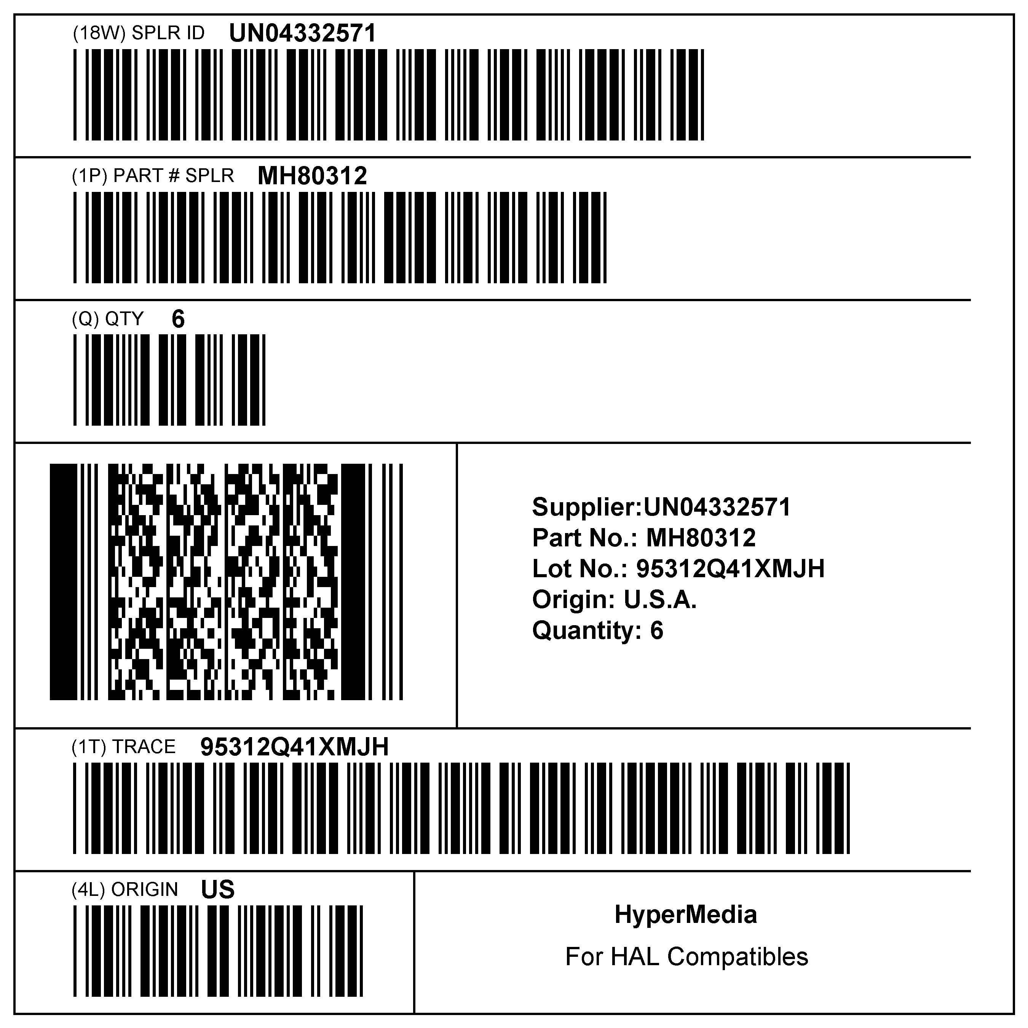

Figure 3: Examples of Terminology for Data Identifier (not to scale)

Proven Systems
Text
Human Readable Interpretation
QuarterMaster
Macintosh PowerBook
tm
G4
0 98756 10001 3
Data Area Title
Title
Supplier: 0098756
Part No: 10001
Serial No: 3193640212
Origin: USA
Quantity: 1
SERIAL
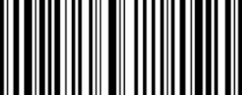
Linear
Bar Code Symbol
Human Translation

(21) 3193640212
Application Identifier

Figure 4: Examples of Terminology for Application Identifiers (not to scale)

When two-dimensional (2D) symbols are used, each 2D symbol should be identified by the following data area titles displayed above the 2D symbol. A 2D symbol containing data meant for:

- The Supplier only shall be identified by the title 'SPLR'.

- The Customer only shall be identified with the title 'CUST'.

- Both the Supplier and the Customer shall be identified with the title 'SPLR/CUST'.

      - Free Text and Data

Human readable information that is not a translation of the bar code information may be provided
according to the requirements of the trading partners.

  - Data Carriers

    - Data Carrier Selection

The choice of use of Linear Bar Code, or 2D symbols, or both as Data Carrier shall be agreed
between trading partners.

    - General Symbology Requirements

Bar code and 2D symbologies used to meet the requirements of clause 5.4.2.1.1 and 5.4.2.2.1
shall be in accordance with the appropriate ISO/IEC JTC1 SC31 standard.

      - Linear Symbologies Requirements

        - Selected Symbologies

The linear bar code symbologies to be used in this standard are:

- Code 39 (reference: ISO/IEC 16388)
- Code 128 (reference: ISO/IEC 15417)
- Interleaved 2 of 5 (reference: ISO/IEC 16390) for ITF-14 symbols
- EAN/UPC (reference: ISO/IEC 15420)

5.5.2.1.2 Symbol Requirements for Linear Bar Code Symbols

Recommended symbol parameters of the bar code symbols are shown in the Table 3 and 4
below. Deviations from the parameters recommended in this standard shall be mutually agreed
between trading partners. The maximum symbol length of a linear bar code symbol should be no more than 9 cm (including quiet zone) so as to allow a common industry width label of 10 cm.

This standard recommends a minimum narrow element width of 0.17mm. Regardless of the
narrow element width the linear symbol shall meet the minimum print quality requirements of
1.5/05/660. If there is difficulty achieving the required print quality level, this standard recommends increasing the narrow element width “X” rather than reducing the print quality requirements.

Table 15: Product Package Label Symbol Requirements Code 39

Code 39: | Recommended Minimum | Recommended Maximum
Ratio of wide to narrow | 2.5 | 3.0
Height of bar code | 5 mm or greater | 5 mm or greater
Narrow element width “X” | 0.17 mm ±10% | 0.43 mm±10%¹
Intercharacter gap | 1x | 3x
Minimum Print quality | 1.5 / 05 / 660 (±10 nm)

Table 16: Product Package Label Symbol Requirements Code 128

Code 128: |  | Recommended  Minimum
Dimensions(nominal) | Module/element width | 0.17 mm (0.25 mm for EAN-128)
Height of bar code | 5 mm or greater
Minimum Print quality | 1.5 / 05 / 660 (±10 nm) / (1.5 / 10 / 660 [±10 nm] for EAN-128)

Table 17: Product Package Label Symbol Requirements Interleaved 2 of 5
(ITF-14 symbols)

ITF-14 | Recommended Minimum | Recommended Maximum
Ratio of wide to narrow | 2.5 | 3.0
Height of bar code | 32 mm or greater | 32 mm or greater
Narrow element width “X” | 0.495 mm | 1.016 mm
Minimum Print quality | 1.5 / 10 / 660 (±10 nm)

ITF-14 Symbols with X-dimensions below 0.635mm (0.025in) should not be printed directly on corrugate with conventional (plate based) processes. Packages and/or containers marked with ITF-14 Symbols with X-dimensions between 1.016mm (0.040in) and 1.219mm (0.048in) are acceptable based on historical specifications, but a migration to the 1.016mm (0.040in) maximum X-dimension should be made on new artwork. The ITF-14 Symbol's bar length ratio target is 2.5:1, and the acceptable range is 2.25:1 to 3:1.

Table 18: Product Package Label Symbol Requirements EAN/UPC

EAN/UPC |  | Recommended  Minimum
Dimensions(nominal) | Module/element width 0.33 mm | See Table 19
Height of bar code | See Table 19
Minimum Print quality | 1.5 / 06 / 660

Table 19: EAN/UPC Dimensions

Magnification factor | Module width (nominal) | EAN-13/UPC-A dimensions [mm]  (Complete symbols)
Magnification factor | [mm] | Width | Height
0.80 | 0.2640 | 29.83 | 20.73
0.85 | 0.2810 | 31.70 | 22.02
0.90 | 0.2970 | 33.56 | 23.32
0.95 | 0.3130 | 35.43 | 24.61
1.00 | 0.3300 | 37.29 | 25.91
1.05 | 0.3460 | 39.15 | 27.21
1.10 | 0.3630 | 41.02 | 28.50
1.15 | 0.3790 | 42.88 | 29.80
1.20 | 0.3960 | 44.75 | 31.09
1.25 | 0.4120 | 46.61 | 32.39
1.30 | 0.4290 | 48.48 | 33.68
1.35 | 0.4450 | 50.34 | 34.98
1.40 | 0.4620 | 52.21 | 36.27
1.45 | 0.4780 | 54.07 | 37.57
1.50 | 0.4950 | 55.94 | 38.87
1.55 | 0.5110 | 57.80 | 40.16
1.60 | 0.5280 | 59.66 | 41.46
1.65 | 0.5440 | 61.53 | 42.75
1.70 | 0.5610 | 63.39 | 44.05
1.75 | 0.5770 | 65.26 | 45.34
1.80 | 0.5940 | 67.12 | 46.64
1.85 | 0.6100 | 68.99 | 47.93
1.90 | 0.6270 | 70.85 | 49.23
1.95 | 0.6430 | 72.72 | 50.52
2.00 | 0.6600 | 74.58 | 51.82

      - Two Dimensional (2D) Symbols Used on Product Packages

The two-dimensional (2D) symbologies identified in this standard are:

- PDF417 (reference: ISO/IEC 15438) – Default symbology

- Data Matrix ECC 200 (reference: ISO/IEC 16022) – May be used with the mutual agreement between trading partners

- QR Code (reference: ISO/IEC 18004) – May be used with the mutual agreement between trading partners

For product package, PDF417 shall be used as the default 2D symbology. With specific mutual agreement between trading partners, either Data Matrix ECC 200 or QR Code may be used. The Data Matrix ECC 200 and QR Code symbologies require 2D-capable image scanning technology.

Users should ensure that the scanning technology they select is capable of reading the symbols they choose to read.

Selection and Use of 2D Symbols (Informative)
2D Symbol Selections
PDF 417, Data Matrix ECC 200, and QR Code are approved to be used for product package labels.

Before choosing a 2D symbology or equipment for your application(s), consideration needs to be made concerning all supply chain materials passing thru your application(s) for scan automation and for label space efficiency. The following table illustrates the major differences to be considered when making these decisions.

Symbology | Linear Imager | Area Imager | Linear Laser | Raster Laser | Label Space Efficiency  (for same “X” dimension)
PDF417 | May be compatible (check with manufacturer) | Compatible | May be compatible (check with manufacturer) | Compatible | Greater than linear bar code
Data Matrix ECC 200 | Not  Compatible | Compatible | Not compatible | Not compatible | Greater than linear bar code and PDF417
QR Code | Not  Compatible | Compatible | Not compatible | Not compatible | Greater than linear bar code and PDF417. Greater than PDF417 and Data Matrix ECC 200 for Kanji and Kana

NOTE:

When evaluating printers and scanners, other special considerations should include:
- Printer capabilities (2D capabilities, DPI, Print Quality, etc.)
- Print Quality Verifier types and capabilities (handheld, fixed, in-line, etc.)
- Scanner types & capabilities (hand-held, fixed, field of view, depth of field, lighting, etc.)

NOTE:

When evaluating printers and scanners, other special considerations should include:
Printer capabilities (2D capabilities, DPI, Print Quality, etc.)
Print Quality Verifier types and capabilities (handheld, fixed, in-line, etc.)

"X" Dimension

The minimum narrow element dimension "X" for the PDF417 and Data Matrix ECC 200, and QR Code symbologies shall be 0,.254mm. The recommended "X" dimensions for each symbology are:

- 0,.254mm for PDF417.

- 0,.38mm (cell size) for Data Matrix ECC 200.

- 0,.38mm (cell size) for QR Code.

The "X" dimension shall be determined by the printing capability of the supplier/printer of the label.

        - Print Quality

Print quality shall be tested in accordance with ISO/IEC 15438 for the PDF417 symbology, ISO/IEC 16022 for the Data Matrix symbology, and ISO/IEC 18004 for the QR Code symbology. For the Product Packaging application, the minimum symbol grade should be 13.0/05/660, where:

- Recommended print quality grade, on 3.0(B) at the point of printing the symbol

- Measurement aperture = 0.125mm (0.005in)

- Light source wavelength = 660 nanometers (nm) ± 10 nm

        - Error Correction Level

The PDF417 symbol error correction level depends on the number of data codewords. A minimum error correction level of 3 is recommended.

Data Matrix ECC 200 uses the automatic error correction as specified in ISO/IEC 16022.

QR Code shall use Error Correction Level "M" as specified in ISO/IEC 18004.

        - Syntax and Semantic Recommendations

Symbols compliant to this standard should use the data identifier semantics specified in ISO 15418/ANS MH10.8.2 and the syntax specified in ISO/IEC 15434 or ANS MH10.8.3.

  - Label Size and Layout

    - Label Size

The dimension of the label should suit the dimensions of the package and may dependent on the space needed for the required information.

    - Label Layout

Label layout refers to the positioning of the fields on a label. Layout of linear bar code or two-dimensional symbols will depend on the available space on a label, packaging techniques and other factors.

When multiple bar code symbols or two-dimensional (2D) symbols are to be placed in line or in contiguous fields, are must be taken to avoid layouts that inhibit scanning the individual data elements. The layout of the label should be designed to accommodate the package size and should facilitate scanning of the bar codes.

Examples of label layouts for patterns are shown in following pages.

    - Examples of Label and Label Layout

      - Examples of Labels with Linear Bar Code and Human Readable Information

Smelly Mature Cheddar Cheese
1054MF
50% Polyester 50% Rayon
Made in E.U.
Mardi Gras
10
010A
5
0
1
2
3
4
5
6
7
8
9
0
0
>
Timmy T-Shirt
Best before: 21 March 2001 Batch: 123ABC

Euro/Kg: NET:

9.10 0.455 Kg

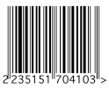 | EURO  4.10

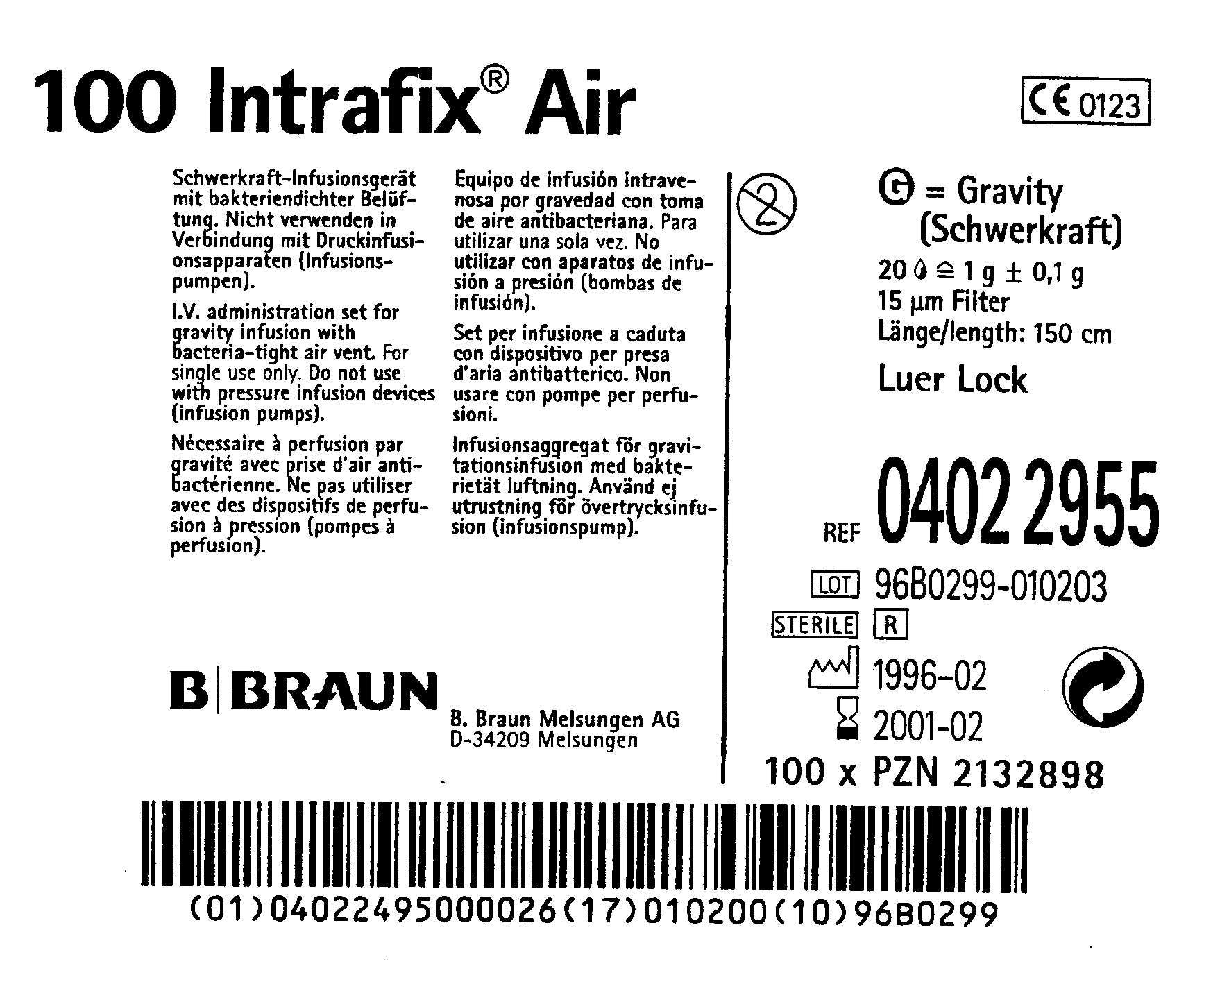

24 x Super Cleaner

Figure 5: Examples of Bar Code and HRI for GS1 Symbols Including Those with Application Identifiers (not to scale)

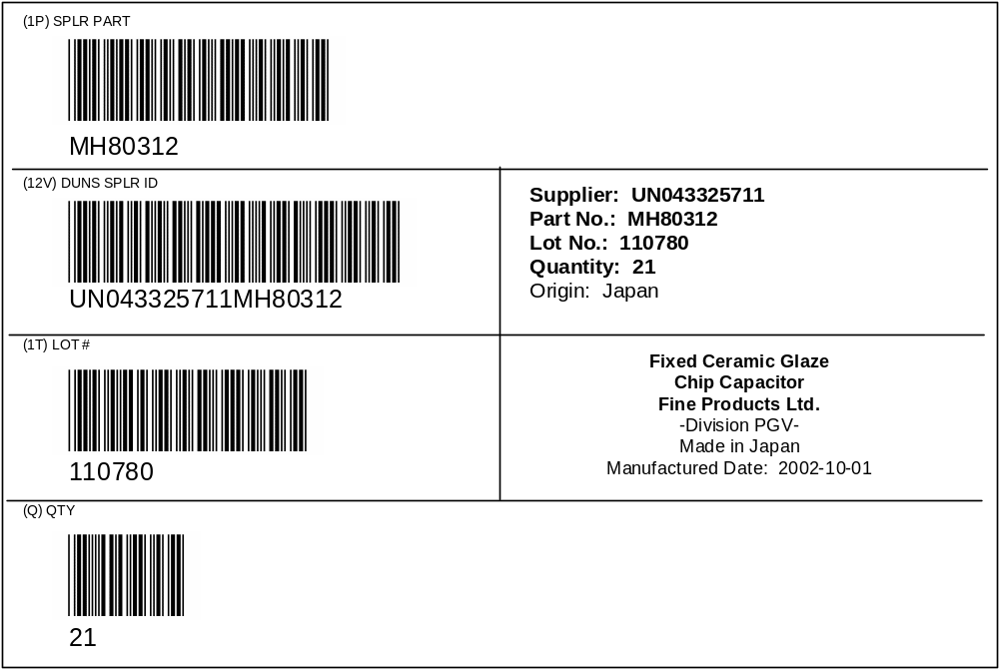

Figure 6: Examples of Terminology for Data Identifiers

      - Labels with 2D Symbols and Human Readable Information
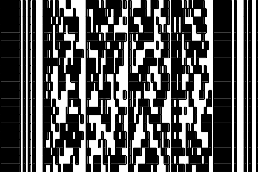
DUNS SPLR LOT # QTY
SPLR ID PART
043325711 MH80312 110780 21

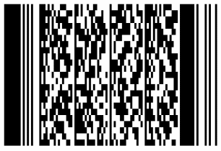
DUNS SPLR LOT # QTY
SPLR ID PART
043325711 MH80312 110780 21

Figure 7: Example of PDF417 with DIs (not to scale)
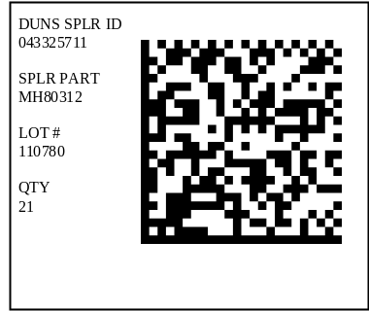

Figure 8: Example of Data Matrix with DIs (not to scale)

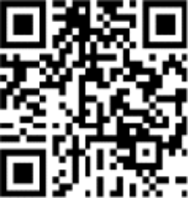
Package
label

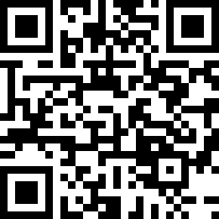
DUNS SPLR ID
043325711

SPLR PART
MH80312

LOT #
110780

QTY
21

Figure 9: Example of QR Code with DIs (not to scale)

      - Label with Linear Bar Code, 2D Symbol and Human Readable Information

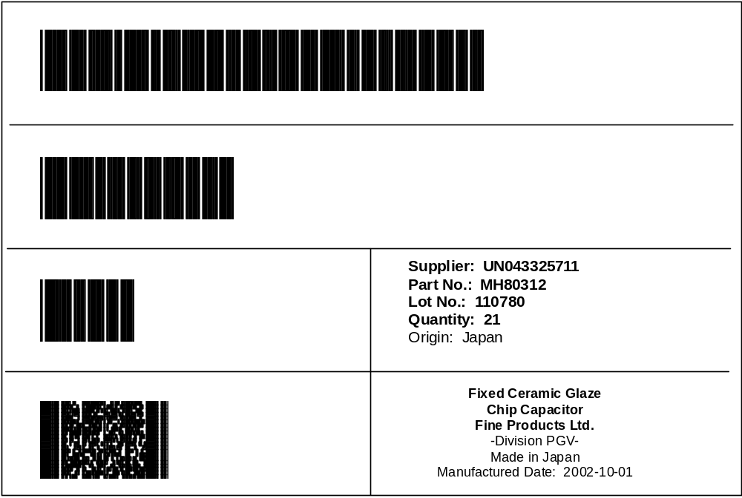

Figure 10: Linear Bar Codes, 2D Symbol, and Human Readable Information

    - Label Location

Label location refers to the positioning of the label on the package. Each label should be located in a position, which facilitates scanning.

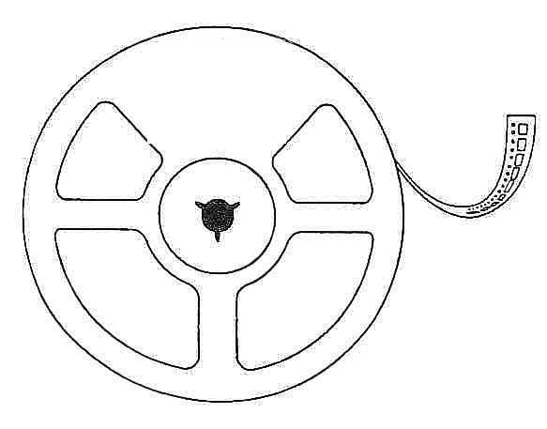
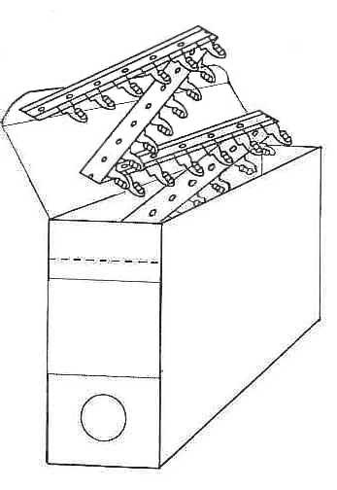

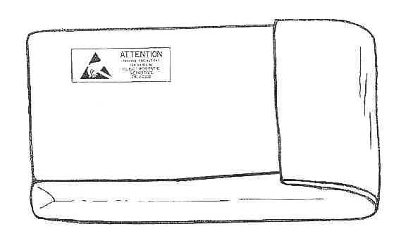
Package
label
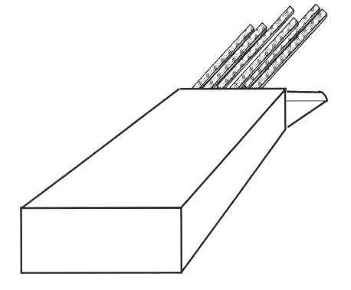

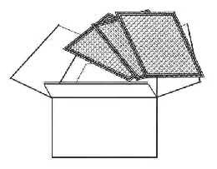
Air Filters

Annex A – Informative References

ANS CEA-624-A Product Package Bar Code Label Standard for Non-Retail Applications – Superceded by this standard.

ANS HIBC-2 Health Industry Bar Code (HIBCC) Supplier Labeling Standard

EIAJ – EDI Standard (Chapter V. Bar Code Label System standard)

IEC CDV 62090 Product Package Labels for Electronic Components Using Bar Code and Two-Dimensional Symbologies

UN/ECE Recommendation 20 (Code list 6411)

Annex B – Glossary (normative)

2D symbol
See "two-dimensional symbol."

alphanumeric
pertaining to data that consist of both letters and digits, and may contain other characters such as punctuation marks

ANSI
American National Standards Institute

area imager
An area imager uses an area CCD or CMOS sensor and fixed illumination to capture a digital image for omni-directional reading of linear bar codes, multi-row codes, and matrix codes (e.g., Data Matrix). Some area imagers are capable of reading Optical Character Recognition (OCR) fonts.

ASC MH 10
An ANSI accredited committee responsible of the development of American National Standards on unit-load and transport-package sizes, package testing standard, definitions and terminology, standardization of unit-load height, sacks and multi-wall bag standards, coding and labeling of unit-loads.

ASC MH 10/SC 8
An ANSI accredited committee responsible for the development of American National Standards on the coding and labeling of transport packages and unit loads, product packaging, and radio frequency identification for returnable containers. ASC MH 10/SC 8 serves as the U.S. Technical Advisory Group (TAG) to ISO TC 122.

ASCII
American Standard Code for Information Interchange: a computer code, as described in ISO 646, consisting of 128 alphanumeric and control characters, each encoded with 7 bits (8 including parity check), used for the exchange of information between computerized systems.

bar
dark element corresponding to a region of a scan reflectance profile below the global threshold

bar code
An array of parallel rectangular bars and spaces arranged according to the encodation rules of a particular symbol specification in order to represent data in machine readable form.

bar code density
number of characters that can be represented in a bar code symbol per unit of measure usually expressed as characters per inch or per centimeter for linear bar codes and per square inch or per square centimeter for multi-row symbologies
NOTE: The width of the narrowest bar or space, the wide: narrow ratio the number of bars and spaces per character and the width of the intercharacter gap, if any, are the controlling factors of bar code symbol density.

bar code reader
device used to capture the data encoded in a bar code symbol, consisting of two parts:
1) the scanner an input device which sends signals proportional to the reflectivity of each successive element of the symbol to the decoder, and
2) the decoder, which examines the signals from the scanner and translates them into recognizable or computer-compatible data. The decoder itself is sometimes erroneously called a reader

bar code symbol
combination of symbol characters and features required by a particular symbology which together form a complete scannable entity

character
member of a set of elements used by agreement, for the organization, representation or control of information
NOTE: Characters may be letters, digits, punctuation marks or other symbols and, by extension, function controls such as space shift, carriage return or line feed contained in a message
[IEC 60050-702 702-05-10]

character set
finite set of characters that is complete for a given purpose
NOTE: ASCII is an example of a character set.

check digit/character
See Symbol Check Character, Data Check Character/Digit.

Code 39
3 of 9 Code (deprecated)
discrete, variable length, bar code symbology encoding the character 0 to 9, A to Z, and the additional characters "-" (dash), "." (period), Space, "$" (dollar sign), "/" (slash), "+" (plus sign), and "%" (per cent sign), as well as a special symbology character to denote the start and stop character, conventionally represented as an "*" (asterisk)
NOTE: Each Code 39 symbol consists of a leading quiet zone, a start symbol pattern, symbol characters representing data, a stop pattern, and a trailing quiet zone. Each Code 39 character has three wide elements out of a total of nine elements. Each symbol consists of a series of symbol characters, each represented by five bars and four intervening spaces. Characters are separated by an intercharacter gap. Each element (bar or space) is one of two widths. The values of the "X dimension" and "N" remain constant throughout the symbol. The particular pattern of wide and narrow elements determines the character being encoded. The intercharacter gaps are spaces with a minimum nominal width of 1X. See ISO/IEC 16388.

Code 128
continuous, variable length, bar code symbology capable of encoding the full ASCII 128 character set, the 128 extended ASCII character set, and four non-data function characters
NOTE: Code 128 allows numeric data to be represented in a compact double-density mode, two data digits for every symbol character. Each Code 128 symbol uses two independent self-checking features, character self-checking via parity and a modulo 103 check character. Each Code 128 symbol consists of a leading quiet zone, a start pattern, characters representing data, a check character, a stop pattern, and a trailing quiet zone. Each Code 128 character consists of eleven 1X wide modules. Each element (bar or space) may consist of one to four modules. Code 128 has three unique character sets designated as Code Set A, B, and C. Code set A includes all of the standard upper case alphanumeric keyboard characters, the ASCII control characters having an ASCII value of 0 to 95, and seven special characters. Code set B includes all of the standard upper case alphanumeric keyboard characters, lower case alphanumeric characters (specifically ASCII character values 32 to 127), and seven special characters. Code set C includes the set of 100 digit pairs from 00 through 99, inclusive, as well as three special characters. The FNC1 character in the first character position after the start code of Code 128 designates that the data that follows complies with the UCC/EAN-128 standards. See ISO/IEC 15417.

code page
A table showing the character allocated to each byte value in a coded character set.

code set
A subset of the character set of a particular symbology. See Character Set.

coded set
set of elements that is mapped onto another set according to a code

codeword
symbol character value, as an intermediate level of coding between source data and the graphical encodation in a symbol

coded character set
coded set whose elements are single characters

component
part, assembly, or raw material which is a constituent of a higher level assembly

component packaging
commercial unit of components defined by the supplier including, if applicable, their means for protection, structured alignment or for automated assembly.
NOTE: Component packaging may include 1) leaded components taped on reels or in ammo box according to IEC 60286-1 and 60286-2, 2) Surface Mount Devices (Surface mount components), taped on reels according to IEC 60286-3 in bulk case, IEC 60286-6, 3) Integrated Circuits (ICs) in stick magazines according to IEC 60286-4, or in matrix trays according to IEC 60286-5. Compare to Product Package.

Country of Origin
manufacturing country wherein the product obtained its present identity as a part, subassembly, or finished product.

customer
in a transaction, the party that receives, buys, or consumes an item or service

data area title
data areas comprised of information in machine-readable or human-readable form.
NOTE: Data areas are identified with the corresponding data area title in human-readable text that may be prefixed, if relevant, by the appropriate identifier.

data character
single numeric digit, alphabetic character or punctuation mark, or control character, which represents information

data check character/digit
digit or character calculated from data and appended as part of the data string to ensure that the data is correctly composed and transmitted
NOTE: compare symbol check character

data codeword
codeword that encodes data according to one of the compaction schemes of a symbology

data element separator
A specified character used to delimit discrete fields of data.

data element title
A part of the data area title for linear code that gives a brief description of the data element, e.g. Part number, Customer nr. The data element may contain abbreviations.

data identifier
DI
specified character or string of characters, that defines the intended use of the data element that follows
NOTE: For the purposes of automatic data capture technologies, Data Identifier means the alphanumeric identifiers, as defined in ISO 15418, GS1 Application Identifiers and ASC MH 10 Data Identifiers and Maintenance and ANS MH10.8.2.

Data Matrix
An error correcting two-dimensional matrix symbology, developed in 1989 with finalized design in 1995 by International Data Matrix, capable of encoding various character sets including strictly numeric data, alphanumeric data, and all ISO 646 (ASCII) characters, as well as special character sets.
NOTE: The symbology has error detection and error correction features. Each Data Matrix symbol consists of data regions that contain nominally square modules set out in a regular array. A dark module is a binary 1 and a light module is a binary 0. There is no specified minimum or maximum for the X or Y dimension. The data region is surrounded by a finder pattern that is surrounded by a quiet zone on all four sides of the symbol. The finder pattern is a perimeter to the data region and is one module wide. Two adjacent sides are solid dark lines used primarily to define physical size, orientation, and symbol distortion. The two opposite sides are made up of alternating dark and light modules. These are used primarily to define the cell structure but can also assist in determining physical size and distortion. The intellectual property rights associated with Data Matrix have been committed to the public domain. See ISO/IEC 16022 for the Data Matrix symbology specification.

decoder
device for restoring information from a coded representation form according to a given code

dot
A localized region with a reflectance that differs from that of the surrounding surface.

dot misalignment within a cell
The distance between the physical center point of a dot and the cell center point.

EAN/UPC
A fixed length, numeric 13-digit bar code symbol adopted by industries, composed of a company prefix assigned by GS1, a product code assigned by the manufacturer, and a modulo 10 check digit as the right-most digit. See ISO/IEC 15420. See U.P.C.

EDIFICE
The Standardized Electronic Commerce forum for companies with interests in Computing, Electronics and Telecommunication. Tiensestraat, 2 3320 Hoegaarden Belgium Telephone: +32.16.76.54.40 Telefax: +32.16.76.53.58.

EIAJ
Electronic Industries Association Japan. EDI Center (EIAJ), 5-13 Nishi-Shimbashi 1-chome, Dai-8 Toyo Kaiji Bldg 6F, Minato-ku, Tokyo 105, Japan, Telephone: +81-3-3593-8323 Telefax: +81-3-3593-8324

Electronic Data Interchange (EDI)
For the purposes of this document, EDI shall mean the computer communication of data which permits the receiver to perform the function of a standard business transaction and is in a standard data format. The exchange of routine business transactions (documents) in a computer-processible format, covering such traditional applications as inquiries, planning, purchasing, acknowledgements, pricing, order status, scheduling, test results, shipping and receiving, invoices, payments, and financial reporting.

element element (symbol character or symbol)
single bar or space in a bar code symbol or a polygonal or circular single cell in a matrix symbol, which according to symbolоgy rules form a symbol character
NOTE: The width of individual elements may be expressed in modules, or in multiples of the X dimension

element width
The thickness of an element measured from the leading edge of an element to the trailing edge of the same element. See "X" Dimension.

erasure
type of error represented by a physically missing character, or a symbol character which has failed to be decoded, as opposed to a substitution error or misdecode

erasure correction
A use of the error correction characters to correct data errors that have known locations (these locations may have insufficient contrast in the image, may fall outside of the image field, or may have incorrect parity for symbologies with symbol character parity). Only one error correction character is required to correct each erasure.

error correcting code
error detecting code which permits the automatic correction of some of the errors detected

error correction
mathematical procedure which allows the detection and rectification of errors to take place.

error correction codeword
codeword in a symbol which encodes a value derived from the error correction codeword algorithm to enable decode errors to be detected and, depending on the error correction level to be corrected

error correction level
degree of error correction capability in a symbology, where this is not fixed but subject to some user choice

error detection
A scheme or action to determine the presence of errors in a data stream.

error detection code
redundant code in which the rules of construction permit the automatic detection of certain errors which have been produced during recording, processing or transfer of information, when these errors have caused a deviation from the rules

European Norm (EN)
A standard of the European Union.

finder pattern
unique pattern in a symbology used to locate symbols conforming to the symbology rules within a field of view

first level assembly
manufactured item or a mechanical assembly of an item comprised of components

format (high-capacity ADC media)
comprised of one or more segments

NOTE: A format contains one format type

format envelope
that which delimits the start and end of data in a given format, consisting of a format header and a format trailer

format header
string of characters, including the format indicator, used to identify the start of a format envelope

format indicator
two-digit numeric code used to identify the specific format type of the application data

format trailer
character used to identify the end of a format envelope

format type
rules under which a specific format is encoded

free text
human-readable information other than what is encoded in the machine-readable medium
NOTE 1: This information may be needed by one or more users of the label.
NOTE 2: An example of free text is a product description.

Global Trade Item Number
GTIN
GS1 Identification Key used to identify trade items.
NOTE: The key is comprised of a GS1 Company Prefix followed by an Item Reference Number and a Check Digit.

GS1
Based in Brussels, Belgium, an organization of GS1 National Organizations that jointly manages the GS1 Systems with GS1 US.

GS1 System
The specifications, standards, and guidelines co-administered by GS1.

GS1 US
Based in the United States, a membership organization that jointly manages the GS1 System with GS1. GS1 US also administers the GS1 System in the United States and Canada.

human readable character
representation of a bar code, data character ,or data check character in a standard eye-readable alphabet or numerals, as distinct from its machine-readable representation

human-readable information
text that appears with and is associated with a machine readable medium, and is intended to be conveyed to a person
NOTE 1 Human-readable information appears typically on a label (e.g. bar code, two-dimensional symbol, radio frequency tag).
NOTE 2 There are four types of human-readable information:
- human-readable interpretation,
- human translation,
- data area titles,
- free text and data.

human-readable interpretation (HRI)
linear bar code or two-dimensional symbol information provided adjacent to a linear bar code, representing the encoded data within a symbol

human translation
human-readable information provided within proximity of the machine-readable medium, representing portions of the information encoded and data field descriptions not encoded in the symbols

Interleaved Two of Five
ITF
bar code symbology where two characters are paired, using bars to represent the first character and the interleaved spaces to represent the second character, encoding the ten digits 0 through 9.
NOTE: Each character has two wide elements and three narrow elements for a total of five elements. Most commonly represented in the U.P.C. Shipping Container Symbol (SCC-14). See ISO/IEC 16390 for the Interleaved 2 of 5 symbology specification.

ITF-14
14-digit implementation of the GS1 GTIN (Global Trade Item Number) when encoded in the Interleaved 2 of 5 symbology
NOTE: The 14-digit version of the GTIN was formerly known as the U.P.C. Shipping Container Symbol (SCC-14).
item
single physical entity or a defined collection of entities having a distinct existence

Japanese Article Number (JAN)
The Japanese equivalent of a U.P.C. A or EAN-13 code. JAN company identification codes are assigned by Distribution Code Center (DCC), 3F Place Canada, 7-3-37 Akasaka, Minato-ku, Tokyo 107, Japan, Voice: +81 3 5414 8505, Telefax: +81-3-5414-8514.

Japanese Industrial Standard
A Japanese standards body responsible for the development of specific Japanese standards, such as those providing a technical specification for a bar code symbology. Japanese Industrial Standards Council (JISC), Japanese Standards Association, 1-3-1 Kasumigaseki, Chiyoda-ku, Tokyo 100-8901, JAPAN, http://www.jisc.go.jp/

linear bar code symbol
graphic representation of data in the form of a combination of symbol characters and features required by a particular symbology, which together form a single-row complete scannable entity
NOTE: Features include quiet zones, start and stop characters, data characters, check characters and other auxiliary patterns

linear imager
A linear imager scanner uses a high-resolution linear CCD sensor and a beam of LED illumination to scan along the X-axis (a line) for reading linear bar codes. Some linear imagers are also capable of reading multi-row codes (e.g., PDF417) when the operator manually swipes the beam over the height of the code.

linear laser
A linear laser scanner uses a mirror assembly to sweep a laser beam along the X-axis (a line) for reading linear bar codes. Some linear lasers are also capable of reading multi-row codes (e.g., PDF417) by manually swiping the beam over the height of the code.

linear symbology
A bar code symbology in which the symbol is formed of a single row of symbol characters. Compare Multi-Row Symbology.

matrix symbology
collection of polygonal or circular elements in a regular pattern to represent data for retrieval by a vision scanning system

message (high-capacity ADC media)
The data stream that is contained within the "message envelope." A message usually consists of two parts: content and envelope.

message(1)
unit of information transmitted from a source to a destination
message(2)
in information theory; communication theory, an ordered sequence of characters intended to convey information

message envelope
that which delimits the start and end of a data stream in a given message, consisting of a message header data, and a message trailer character

message header
string of characters used to identify the start of a message envelope

message trailer character
End of Transmission character, "EOT", ", (ASCII/ISO646 Decimal “04”) (ASCII/ISO646 Hex "04") which serves to define the end of a message.

multi-row symbology (also stacked symbology)
bar code symbology in which the symbol consists of two or more vertically adjacent rows of symbol characters

PDF417
error correcting two-dimensional multi-row symbol developed in 1992 by Symbol Technologies, PDF417 symbols are constructed from 4 bars and 4 spaces over 17 modules
NOTE: The symbol size is from 3 to 90 rows. There is no specified minimum or maximum for X or Y dimension. With at least the recommended minimum level of error correction, the recommended Y dimension is 3X. With less than the minimum recommended level of error correction, the recommended Y dimension is 4X. A quiet zone of 2X is specified on each side of a symbol. Because of delta decode techniques the symbology is immune from uniform bar width growth. PDF417 supports cross-row scanning. The intellectual property rights associated with PDF417 have been committed to the public domain. See ISO/IEC 15438 for the PDF417 symbology specification.

print quality
degree to which a printed optical symbol complies with the requirements which are specified for it, such as dimensions, reflectance, edge roughness, spots, voids, etc., which will affect the performance of the scanner

product package
first tie, wrap or container of a single item or quantity thereof that constitutes a complete identifiable pack
NOTE: A product package may be an item packaged singularly, multiple quantities of the same item packaged together or a group of parts packaged together. For the purposes of this document the term “product package” includes component packages and packaging intended for storage and transport.

QR Code
error correcting matrix symbology, introduced in 1994 by Denso Corporation, consisting of an array of nominally square modules arranged in an overall square pattern, including a unique finder pattern located at three corners of the symbol and intended to assist in easy location of its position, size and inclination
NOTE: A wide range of sizes of symbol is provided for together with four levels of error correction. Module dimensions are user-specified to enable symbol production by a wide variety of techniques. The symbol size (not including quiet zone) is 21 by 21 modules to 177 by 177 modules. The symbology efficiently encodes Kanji and Kana as well as encoding numeric, alphanumeric, and 8-bit byte data. See ISO/IEC 18004 for the QR Code symbology specification.

quiet zone
area free from interfering markings which must surround a bar code symbol and, in particular, precede the start character and follow the stop character

raster laser
Raster laser scanners use two mirror assemblies, one mounted perpendicular to the other, to sweep the laser beam over both the X-axis and the Y-axis for reading linear bar codes and multi-row codes.

reader
functional unit that is used for the acquisition or interpretation of data from a storage device, from a data medium, or from another source

resolution
width of the narrowest element capable of being read by the scanner equipment under test conditions

scanner
device that converts optical information (e.g. a printed bar code or two dimensional symbols) into electrical signals for subsequent decoding and transmission to a computer

segment
logical group of data elements, specifically, a logical portion of an EDI or high capacity ADC message

segment terminator
The single character used to separate segments

semantics
means by which the purpose of a field of data is identified
Examples: The semantic examples used in automatic data capture include ISO/IEC 15418/ANS MH10.8.2 Data Identifiers, GS1 Application Identifiers, X12/EDIFACT/CII EDI Data Element Qualifiers

serial number
code assigned by the supplier to an entity for its lifetime, (e.g. computer serial number, traceability number, contract tool identification)

space
A light element corresponding to a region of a scan reflectance profile above the global threshold.

speck
See Spot.

spot
ink or dirt mark or other area of low reflectance in an area of a symbol which is intended to be of high reflectance
cf. void

structure
order of data elements in a message

supplier
in a transaction, the party that produces, provides, or furnishes an item or service

symbol
graphic representation of a concept that has meaning in a specific context

symbol character
physical representation of the codeword as a pattern of dark and light elements
NOTE: There may be no direct one-to-one mapping between symbol character and data character or auxiliary character. Decoding through the compaction rules is necessary to identify the data.

symbol check character
symbol character calculated from the other symbol characters in a bar code symbol in accordance with an algorithm defined in the symbology specification and used to check that the bar code has been correctly composed and read
NOTE: the symbol check character does not form part of the data encoded in the symbol

symbology
standard means of representing data in optically machine readable form

symbology identifier
sequence of characters generated by the decoder and prefixed to the decoded data transmitted by the decoder, that identifies the medium from which the data has been decoded

syntax
manner in which data is put together to form messages, including rules governing the use of appropriate identifiers, delimiters, separator character(s), and other non-data characters within the message
Note: Syntax is the equivalent to grammar in spoken language.
Examples: The syntactic example used in automatic data capture include ISO 15434/ANSI MH10.8.3 - Syntax for High Capacity ADC Media

traceability identification
code assigned to identify or trace a unique group of entities (e.g. lot, batch, item, revision/version or serial number)

traceability number
code assigned by the supplier to identify/trace a unique group of entities, (e.g. lot, batch,)

two-dimensional
(2D) symbols
optically readable symbols that must be examined both vertically and horizontally to read the entire message
Note: Two-dimensional symbols may be one of two types: matrix symbols and multi-row symbols.
Note: Two dimensional symbols have error detection and may include error correction features

U.P.C.
Universal Product Code
A fixed length, numeric 13-digit bar code symbol adopted by the retail industries, composed of a company prefix assigned by GS1 US, a product code assigned by the manufacturer, and a modulo 10 check digit as the right-most digit.
NOTE: For international compatibility with GTIN-13 the 13th digit is a derived 0 in the left-most position. See ISO/IEC 15420 for the U.P.C. symbology specification.

verification
technical process by which a symbol is measured to determine its conformance with the specification for that symbol

void
area of high reflectance in an area of a bar code symbol which is intended to be of low reflectance
NOTE: compare speck, spot.

X dimension
specified width of the narrow elements in a bar code symbol or the specified width of a single element in a two dimensional symbol
cf. Z Dimension

Y dimension
specified height of the elements in a linear bar code symbol or a row in a multi-row symbology
cf. Bar Height

Z dimension
average achieved width of the narrow elements in a bar code symbol, equal to half the sum of the average narrow bar width and the average narrow space width, in two-width symbologies, or to the quotient of the average overall character width divided by the number of modules per character in modular symbologies

Bibliography

- IEC 60194, IEC Terms and Definitions
- IEC 60286-1, Packaging of components for automatic handling - Part 1: Tape packaging of components with axial leads on continuous tapes
- IEC 60286-2, Packaging of components for automatic handling - Part 2: Tape packaging of components with undirectional leads on continuous tapes
- IEC 60286-3, Packaging of components for automatic handling - Part 3: Packaging of surface mount components on continuous tapes
- IEC 60286-4, Packaging of components for automatic handling - Part 4: Stick magazines for dual in-line packages
- IEC 60286-5, Packaging of components for automatic handling - Part 5: Matrix trays
- IEC 60286-6, Packaging of components for automatic handling - Part 6: Bulk case packaging for surface mount components
- IEC 62090, Product package labels for electronic components using bar code and two-dimensional symbologies
- ANS CEA-624-A Product Package Bar Code Label Standard for Non-Retail Applications – Superseded by this standard.
- EIAJ – EDI, Standard (Chapter V. Bar Code Label System standard)
- EDIFICE, Bar Code Label Implementation Guide for Product Package
- UN/ECE, Recommendation 20 (Code list 6411)

Normative Reference Acquisition
IEC Standards:
- Global Engineering Documents, World Headquarters, 15 Inverness Way East, Englewood, CO USA 80112-5776; Phone 800-854-7179; Fax 303-397-2740; Internet http://global.ihs.com; Email global@ihs.com
- IEC Central Office, 3, rue de Varembe, PO Box 131, CH-1211 Geneva 20, Switzerland; Phone +41 22 919 02 11; Fax +41 22 919 03 00; Internet http://www.iec.ch; Email pubinfor@iec.ch

Narrow element width definition is to satisfy the needs of laser based and imager based scanning. While the minimum is recommended for open systems, agreement between trading partners can specify a more narrow element width.

